**JSBootcamp Exam**

Your task is to develop a simple application named **search**. The application searches for all files that contains a specified string under the current directory

The application should be written using the JavaScript programming language. The application should be executed under the NodeJS platform. For more information on developing NodeJS applications please read [here](https://nodejs.org/en/)

For example, when the user executes the following command:

**C:\MyFolder> node search.js txt Ori**

The application searches for all files with the extension **txt** under **C:\MyFolder (**including subdirectories) that contain the string **Ori**. Once the search completes, the application displays the list of all matching files (full path)

To simplify testing of the application you should submit a link to a Github repository. You can read more about that [here](https://help.github.com/articles/create-a-repo/). We will clone the repo using “git clone” and then run the commands as below. Please follow below examples for the expected behavior

Example 1: Running application without any parameter prints a simple help message

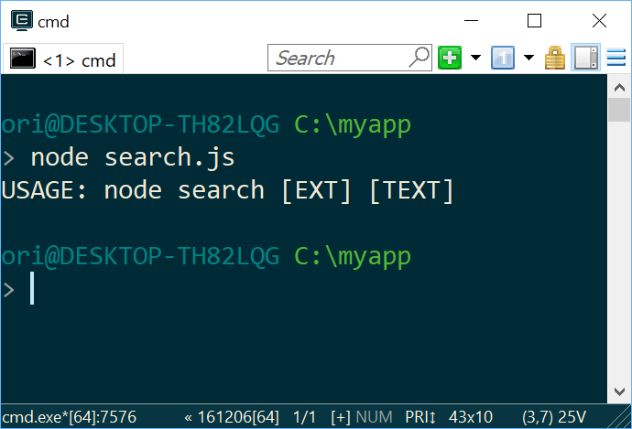

Example 2: Looking for all files with “txt” extension that contain the word “ori”

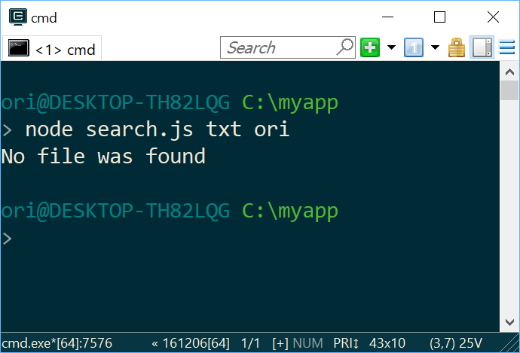

Example 3: Looking for all files with “js” extension that contain the word “file”

